
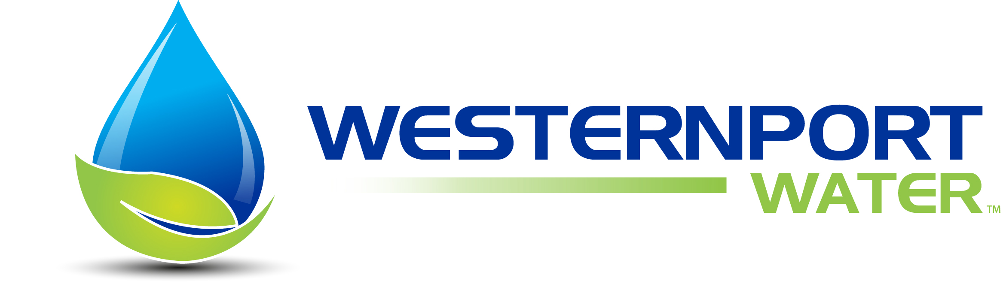

Photography Competition 2012

Terms & Conditions

- Entries are open to schools & individuals located within the Westernport Water service area
- Photographs must have been taken between 1 April 2011 to 20 July 2012

- Photographs must have been taken by the entrant.

- Entries from entrants under the age of 18 years must provide details of parent/guardian that approves the entry of the photograph.

- Where the photograph includes the image of a person or people the person or people whose image(s) is used must have given you permission/consent to submit their image into this competition. The consent is the responsibility of the entrant and by agreeing to these terms and conditions the entrant agrees that they have obtained this consent. Westernport Water™ and savewater!® will not be held responsible/accountable for promoting/displaying personal images of people/persons who have not agreed to their images being used in the public domain.
- Photographs must be submitted in JPEG or TIF format
- Entry forms must be completed in English
- Photographs must be uploaded onto www.savewater.com.au No hardcopy photographs will be accepted. Retain a copy of your entry for your own purposes.
- Entrants are allowed to submit a maximum of 3 photographs, with each photograph only permitted to be entered once and only in one sub-category.

- The entrant acknowledges that the use of the photograph will result in readers and viewers being able to identify the entrant.
- Entries close at 5pm (AEST) on Friday 20th July 2012. Strictly no extensions will be granted.
- Westernport Water™ reserves the right to request additional information at any time.
- Westernport Water™ reserves the right to reclassify, disqualify or withdraw an entry or award at any time if entry conditions are not met.

- savewater!® reserves the right to not submit an entry to the judging panel if it does not meet the entry criteria.

- savewater!® reserves the right to change the conditions of entry at any time. You will be notified of any such changes using the electronic contact details you have provided.

- All entries will be evaluated in good faith by the judging panel. The judges’ decision is final and no correspondence or discussion will be entered into.

- All entries will be judged on the basis of the documents submitted to the judging panel.

- Details of the judging procedures cannot be disclosed or discussed before, during, or after the event.

- The judging panel reserves the right to make no award in a particular category or categories if insufficient entries are received, or in the judging panel’s view the standard of entries are not sufficiently high enough to merit an award.

- The entrant must give the rights described below to savewater!® and Westernport Water™

- Without charge unconditionally give Westernport Water™, savewater!® it’s members and savewater!® supporters the right to:

  - reproduce the photograph using my image in printed or digital format; and

  - use the photograph using my image in any printed, digital or other form including but not limited to print, TV, radio, Internet and electronic mediums, in publications and reports, displays, editorials, newsletters, and other forms of any kind where the use of the photograph is linked, to water conservation or the promotion of future competitions.

- Westernport Water™ and savewater!® Management may use, publish or authorise others to publish details of an entry, including supporting materials and photographs, for the purposes associated with savewater!® Marketing and promotion programs (sympathetic to issues of commercial confidentiality). The entrant warrants that the use of the material by Westernport Water™ and savewater!® Management in this way will not constitute a breach of copyright. The entrant indemnifies Westernport Water™ and savewater!® Management as a result of a breach of this warranty by the entrant.

- The media comment including spoken or written editorial, and photographic display of any or all of the entries will be at the discretion of Westernport Water™ and savewater!® Management and the appropriate media.

- To indemnify Westernport Water™ and savewater!® Management in respect of any alleged discrepancy, error, omission, or misrepresentation in an editorial given.

- No employee or immediate family of savewater!® are permitted to enter. “Immediate family” means spouse, parent, natural or adopted child, and sibling (whether natural or adopted by a parent), whether or not they live in the same household as the savewater!® employee.

