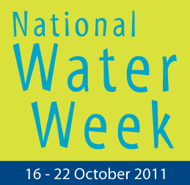 | Poster Competition
The National Water Week Poster Competition is on again! Primary School students are asked to create a poster reflecting water related issues which are important to them.
Teachers – this is a great activity for the classroom in the lead up to National Water Week. Last year, over 3,000 entries were received from Victorian Primary Schools
Poster entries are invited in four categories:
- Prep,
- Years 1 & 2
- Years 3 & 4
- Years 5 & 6
Great prizes can be won by both the student AND school
Entries will be judged locally. Winners in each category will then be submitted for state judging.
Winners will be chosen using the following criteria:

- How well the poster conveys water related issues
- How well it can be reproduced to promote National Water Week
- Appearance: attractively displayed in colour.

- How good it looks from a distance
- Effective use of art materials
- Originality of design or innovative concept
- Poster MUST be 30x40cm (A3) in size
.

Any medium, including paper, can be used as long as it is at least 30x40cm (A3) in total.
Any art material can be used including paint, textas, coloured pencils,
collage materials, photography, computer graphics.
An official entry form must be securely attached to the back of each poster.

Entries must reach Westernport Water by 4pm Monday 12th September 2011.
State winners and runner-ups will be presented during NWW activities in your Region.
VicWater is committed to protecting information provided in accordance with the principles of the Information Privacy Act 2000. Information contained in your entry form/s may be stored and used by VicWater for the purpose of managing National Water Week events. Failure to provide contact details for entry into the NWW Competitions will constitute an invalid entry. This information may be disclosed to relevant government agencies or other stakeholders for these purposes.
For further information please contact Geoff Russell Communications and Media Manager of Westernport Water on 03 5956 4140.

National Water Week Poster Competition in Victoria
Proudly supported by: |  |  | Proudly brought to you by:
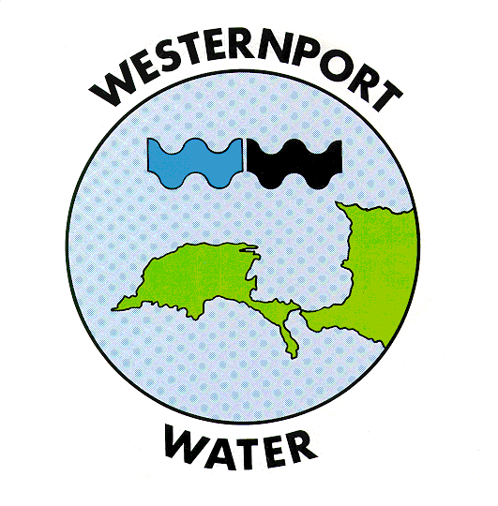 |  |  | 
 |  |  | 

