Poster Competition Entry Form
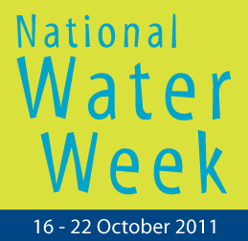 | PLEASE USE BLOCK LETTERING |  | Student Name:  Date of Birth:
 |  |  | School (Full Name & Address)
 |  |  | Year Level  (Circle Appropriate) | Prep | Yrs 1 & 2 | Yrs 3 & 4 | Yrs 5 & 6
Contact Person (Consenting Legal Guardian)
I have read, and accept, the conditions of entry
(please tick the box, write your name and sign)
Print Name:
Signature:
 |  |  | Phone:
Entries must reach Westernport Water by
4pm Monday 12th September 2011
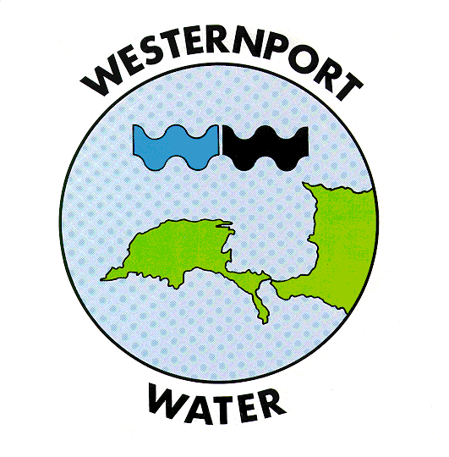 |  | Westernport Water  2 Boys Home Road  Newhaven Vic, 3925  1300 720 711
CONDITIONS OF ENTRY Entries must be of A3 size. By submitting the entry form, entrants will assign a limited copyright of the image to the competition organisers enabling reproduction of the image for public displays and publications (both printed and digital) in conjunction with the competition AND for the purpose of publication in printed and digital material promoting water conservation, including National Water Week in subsequent years. Artists will be credited whenever the posters are used. Entries from students under the age of 18 must have adult consent. Signing of the entry form for this competition constitutes acceptance of these conditions of entry.
* For further information please contact Geoff Russell on 0359564140

National Water Week Poster Competition in Victoria
Proudly supported by: |  |  | Proudly brought to you by:
 |  |  | 
 |  |  | 

