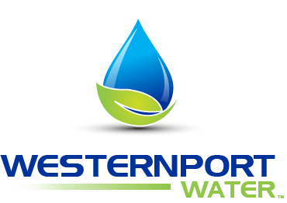
TERTIARY SCHOLARSHIP PROGRAM
2012

APPLICATION FORM
Applicants Details
Name:
Primary Place of Residence:
Postal Address (if different):
Phone: |  | Mobile:
Email address:
Secondary College attended:
Tertiary Course Details:
Course Name:
University:
Length of course in years:
Career Goal (if known):
Selection Criteria:
Briefly address each of the Selection Criteria in a separate document and attach to your application. Please note one paragraph per criteria is sufficient.
- Why you believe you are the best applicant for this scholarship.
What personal attributes you possess that makes you the person that Westernport Water should select. This should include details on any work or other life experiences that you believe are relevant.
- An understanding of the products and services that Westernport Water delivers.
- An understanding of how the course study to be undertaken could be applied to a water business.
- An ongoing commitment to the South West Gippsland region.
- Demonstrated communication skills.
- Demonstrated ability to operate effectively as part of a team.

Additional Documentation Check List:
Please attach copies of the following documents:
 | Statement of results and ENTER for VCE or equivalent |  |  | Confirmation of your acceptance of VTAC offer
 | Confirmation of enrolment at University (if available) |  |  | A statement of support from your secondary college or faculty
Understanding and Acknowledgment of the Conditions of this Scholarship:
I understand and acknowledge:
If successful I will be required to enter into a Scholarship Agreement with Westernport Water.
This Agreement includes an Employment Agreement.
If I do not fulfill the ongoing requirements of the Agreement I may be required to refund some or all scholarship monies received.

Name:
Signature:
Date:
Please address your application to:

Merryl Todd
General Manager Employee & Customer Relations
Westernport Water
2 Boys Home Road
NEWHAVEN VIC 3925

This form and supporting attachments must be received by us by 5:00pm 31 January 2012

